Project Report

Multiplayer Chess Game

Lecturer: Dr. Aqsa Aslam

Instructor: Mr. Ubaidullah

Course: Computer Networks (CS-3001/CL-3001)

Semester: Spring 2024

Section: BCS-6E

12.05.2024

**─**

Muhammad Hamza (K21-4579)

Muhammad Salar (K21-4619)

Fahad Yousuf (K21-4839)

# **Abstract:**

Online Chess is a Python-based chess application that focuses on providing a rich multiplayer and online gameplay experience. The project aims to offer a user-friendly interface, seamless gameplay, and a platform for chess enthusiasts to compete against each other in real-time over a network. This report provides a detailed overview of the project, including its objectives, features, technical implementation, development process, and potential impact.

# **Introduction:**

Chess is a timeless game that has captivated players for centuries. With the advent of technology, digital chess applications have become increasingly popular, allowing players to enjoy the game anytime, anywhere. The projects aims to take this a step further by providing a multiplayer and online chess platform that offers a realistic and engaging gameplay experience.

# **Features:**

Online Chess offers a range of features to enhance the gameplay experience:

* ***Multiplayer Mode:*** Players can compete against each other on the same device, taking turns to make their moves.
* ***Online Mode:*** Players can connect over a network to play against each other in real-time, with the option to chat and interact during the game.
* ***User Interface:*** The application features a graphical user interface that is intuitive and easy to use, with visual cues to help players understand the game state.

# **Installation:**

To install the game, ensure Python 3.7 is installed on your system. You can install the Pygame library using the following command:

pip install pygame

# **Usage:**

To play the game, start the server by running python server.py. Then, open two terminals and run python py_chess.py in each. Select your preferred mode and enjoy.

# **Technical Implementation**

## **1. Networking**

Online Chess uses sockets for networking, allowing players to connect to a server and communicate with each other during gameplay. The server manages player connections, game sessions, and facilitates the exchange of game data.

## **2. Game Logic**

The game logic of the project follows the standard rules of chess, including move validation, checkmate detection, and game state management. The application also handles player turns and enforces time controls for online gameplay.

## **3. User Interface**

The user interface is built using Pygame, a popular library for creating 2D games in Python. The interface provides a visual representation of the chessboard, pieces, and player interactions, making it easy for users to understand and play the game.

# **Development Process**

The development involves several stages, including planning, design, implementation, and testing. The project was developed using an agile approach, with regular feedback from users and stakeholders to ensure that the final product met the desired requirements.

# **Potential Impact**

The project has the potential to make a significant impact on the chess community by providing a platform for players to connect, compete, and improve their skills. The application's user-friendly interface and engaging gameplay experience make it suitable for players of all ages and skill levels, contributing to the overall growth and popularity of chess as a recreational and competitive game.

# **Screenshots:**

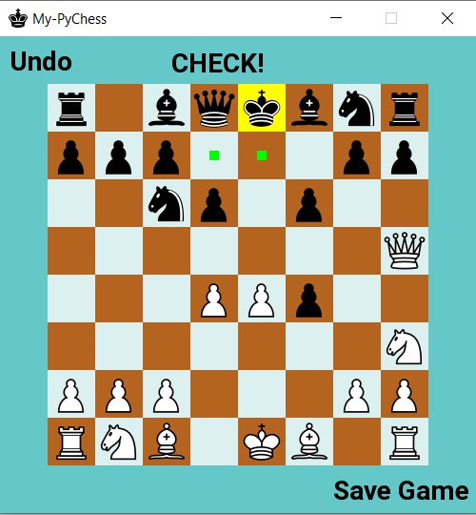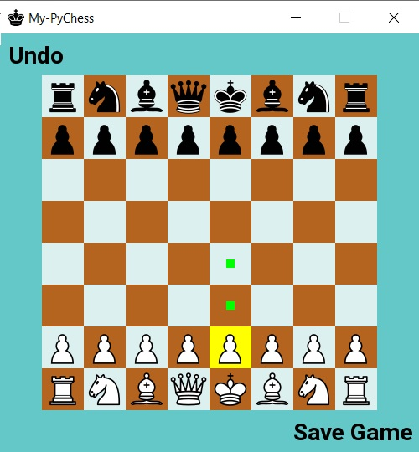

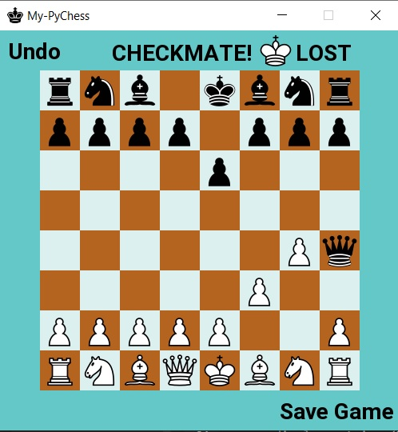

# **Challenges:**

The project faced challenges in managing multiple connections and game states simultaneously, as well as ensuring smooth gameplay and synchronization between clients.

# **Future Improvements:**

Future improvements to the game could include implementing chat functionality between players, adding support for custom game modes and rules, and enhancing the user interface with additional graphics and animations.

# **Conclusion:**

Online Chess provides a platform for chess enthusiasts to enjoy the game with random opponents online. It demonstrates the use of Python for networking and Pygame for creating interactive user interfaces.

# **Acknowledgements:**

The project acknowledges the Pygame community for the Pygame library and the Python community for the sockets module.

# **References:**

* Pygame documentation: <https://www.pygame.org/docs/>
* Python sockets module documentation:<https://docs.python.org/3/library/socket.html>